Name: Period:
Land Management: Succession Webquest
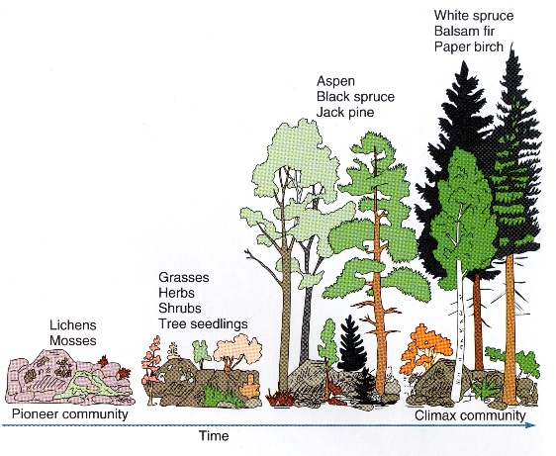

Objectives: After studying this material you should be able to:
□ Describe an ecosystem and explain how the biological community interacts with its environment.
□ Explain the role of disturbance in (natural and managed) ecosystems and its relationship to succession.
□ Explain what primary succession is and give some real world examples.
□ Explain what secondary succession is and distinguish it from primary succession.
□ Describe how living components in the ecosystem change nonliving components during succession.

Visit the web link: http://www.countrysideinfo.co.uk/successn/summary.htm

- How is primary succession different from secondary succession?

- Describe the example of secondary succession indicated in the simulation

- Imagine a lawn on campus or in someone's yard. Are there any examples of succession there now? If no one maintained it for five years, what might it look like? What would it look like after 10 years? 50? 100?

Visit the link, read the introduction, watch the animation, take the quiz, and answer the following questions: http://wps.prenhall.com/wps/media/objects/2688/2752944/Web_Tutorials/23_A02.html

- What are some of the “pioneer” species in glacial moraines?

- How do Dryas shrubs affect nitrogen content in soil?

- How do the alder trees influence spruce tree growth?

- Is a glacier an example of primary or secondary succession? Why?

- Describe the pattern of primary succession the Glacier Bay area. Are all of the regions of the bay at same stage of succession process? What factors might explain this?

Vist the link and click through the animation, then answer the following questions: http://www.wiley.com/college/strahler/0471480533/animations/ch23_animations/animation1.html

- Is the story of bog succession an example of secondary or primary succession? Why?

Visit the link https://www.youtube.com/watch?v=k03vxRYsJ4Y and answer the following questions:

- What is the disturbance illustrated in this animation?

- Is this an example of secondary or primary succession? Why?

- Describe what happens to the complexity/biodiversity of the forest over the course of hundreds of years after the initial disturbance.

- Fire is one cause of secondary succession. List at least four other examples of secondary succession.

Fire Succession in San Diego County. Click on each of the links and answer the associated questions:

Chaparral http://interwork.sdsu.edu/fire/resources/chapparal-charecteristics.htm

- What is the difference between and obligate seeder and obligate sprouter?

- According to the article what has been the impact of fire suppression strategies in general in chaparral communities in San Diego.

Mixed Coniferous Forest http://interwork.sdsu.edu/fire/resources/conifer-forest.htm

- How have fire suppression efforts in coniferous forest influenced shade tolerant plants?

- In National Forests, government policy has been to suppress forest fires whenever possible for the last century. Now some regions are starting to allow fires to burn. Based on what you know about succession, what impact do you think this might have in the mixed coniferous forests of Sand Diego and areas like it?

Click on the link http://interwork.sdsu.edu/fire/curricula/documents/LearningtolivewithFire.pdf

- What are some of the adaptations common to plants and trees in fire prone areas?

Reflection: How do you think wildfire and the wildfire recovery process influence animal biodiversity?

