STATION 1

- Describe the structure of DNA.
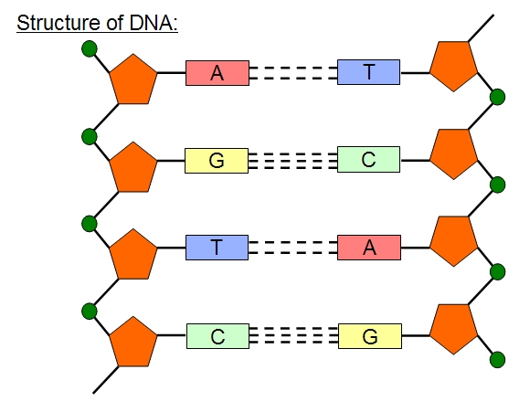
B

A

- What does DNA stand for?
- What are the pentagons?
- What are the nitrogen bases?
- What weak bonds hold the complementary bases together?
- What is DNA made of?
- What does the circled structure A represent?
- What does the circled structure B represent?
- What is a monomer of DNA?
- What are the 3 parts of a nucleotide?
- What type of biomolecule is DNA?
- Why is the sequence of nucleotides in a gene important?
- What is the genetic code?
- What is the shape of DNA?
- Circle a gene in the picture of DNA below.

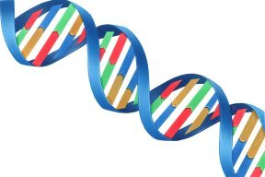

- What is the function of DNA?

STATION 2

- Below is a strand of DNA. DNA in the cells exists as a double helix.
What needs to be added to it to make it a double helix?
Give the complementary nucleotide sequence.

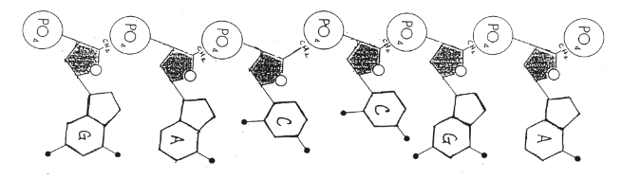

- If the strand of DNA (gene) above undergoes transcription, what will the sequence of the mRNA be?

- What anticodons on the tRNA would compliment the codons on the mRNA?

- After translation, what would the amino acid sequence be for this
section of mRNA?

- What is a codon?

- Circle a CODON on the mRNA strand (refer to question 2).

STATION 3

- Compare RNA and DNA in the following table.

 | DNA | RNA
Sketch a molecule

Name of sugar

Bases
Number of strands
Where in the cell?
Function

- What are the functions of each type of RNA?

- Messenger RNA –
- Transfer RNA –
- Ribosomal RNA (ribosome) –

STATION 4
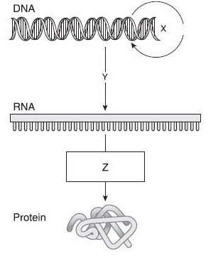

Y

- What cellular process is shown above?
- What process does Y represent?
- What is the purpose of this process?
- What is the product of this process?
- Where does this process take place?

- What process does Z represent?
- What is the purpose of this process?
- What is the product of this process?
- Where does this process take place?

STATION 5
- What is a mutation?
- What is a mutagen? Give an example.

- Create a insertion frameshift mutation using the original DNA strand (gene).

Original DNA strand (GENE sequence): CTG GGG CAG TTA ACC
Mutated DNA strand (Insertion - frameshift): _______________________
mRNA: _______________________
tRNA: _______________________
Amino Acid sequence (protein): _______________________

4. Identify each point mutation:
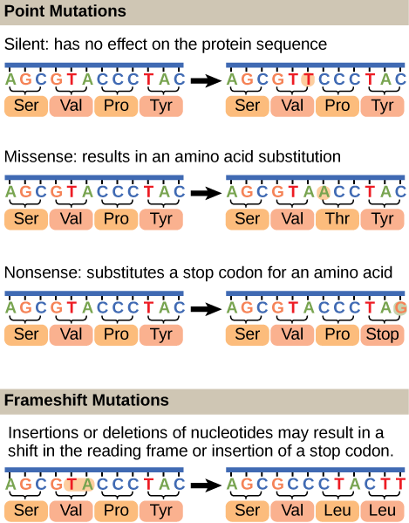
A. Silent - no change in AA

B. Missense - substitution of one AA

C. Nonsense - substitution of a STOP codon for an AA

D. Frameshift Deletion - shift in a reading frame to the left. All amino acids are changed from the point of mutation.

STATION 6
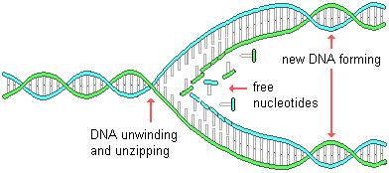
C

B

A

- Which cellular process is shown above?
- What is happening at the point A?
- What is happening at the point B?
- What is happening at the point C?
- What is the product of this process?
- When do cells make this product?
- Why this process is called semi conservative?
Draw your answer:

- Occasionally, an error is made during this process. For example, an incorrect base pair may be included by DNA polymerase. What do we call errors made in DNA?
- Such errors can be passed on to the new generation (offspring). The errors in what type of cells can be inherited?

STATION 7

- What is a gene expression?
- What is the product of gene expression?
- What do the products of gene expression give rise to?
- What are the two major steps of gene expression?
- What process in the gene expression converts the gene’s code into mRNA?
- When information in mRNA is made into a protein by ribosomes, the process is called as ____.
- Gene expression means that the information in a gene is synthesized into a _
- What molecules ultimately control a cell’s traits (phenotype)?
- Do all cells in an organism have the same genes?
Are they all turned on or expressed? Explain.
- Why are some genes expressed in one type of cell but not others? Give an example.
- Can a cell regulate how much or when a gene is expressed?
- What plays a role in the regulation of gene expression?
- If the following gene was expressed into a protein, what would the amino acid sequence be?
TAC TTA GGA CAG

STATION 8

Go to the following website and complete the virtual activity: https://learn.genetics.utah.edu/content/basics/transcribe/

When you are finished, Mrs. Lyle or Mrs. Kubajak need to check you off.

ANSWER SHEET - Review Stations
STATION 1
- What does DNA stand for?
- What are the pentagons?
- What are the nitrogen bases?
- What weak bonds hold the complementary bases together?
- What is DNA made of?
- What does the circled structure A represent?
- What does the circled structure B represent?
- What is a monomer of DNA?
- What type of biomolecule is DNA?
- Why is the sequence of nucleotides in a gene important?

- What is the genetic code?
- What is the shape of DNA?
- Circle a gene in the picture of DNA below.
- What is the function of DNA?

STATION 2
- Give the complementary nucleotide sequence.
- If the strand of DNA (gene) above undergoes transcription, what will the sequence of the mRNA be?
- What anticodons on the tRNA would compliment the codons on the mRNA?
- After translation, what would the amino acid sequence be for this section of mRNA?
- What is a codon?
- Circle a CODON on the mRNA strand (refer to question 2).

STATION 3
Messenger RNA: ____________________________

Transfer RNA: ____________________________

Ribosomal RNA (ribosome): ____________________________
 | DNA | RNA
Sketch a molecule

Name of sugar
Bases
Number of strands
Where in the cell?
Function

STATION 4
- What cellular process is shown above?
- What process does Y represent?
- What is the purpose of this process?
- What is the product of this process?
- Where does this process take place?
- What process does Z represent?
- What is the purpose of this process?
- What is the product of this process?
- Where does this process take place?
STATION 5
- Which cellular process is shown above?
- What is happening at the point A?
- What is happening at the point B?
- What is happening at the point C?
- What is the product of this process?
- When do cells make this product?
- Why this process is called semi conservative?
Draw your answer:

- Occasionally, an error is made during this process. For example, an incorrect base pair may be included by DNA polymerase. What do we call errors made in DNA?
- Such errors can be passed on to the new generation (offspring). The errors in what type of cells can be inherited?
STATION 6
- What is a gene expression?

- What is the product of gene expression?
- What do the products of gene expression give rise to?
- What are the two major steps of gene expression?
- What process in the gene expression converts the gene’s code into mRNA?
- When information in mRNA is made into a protein by ribosomes, the process is called as ___________
- Gene expression means that the information in a gene is synthesized into a _____________________
- What molecules ultimately control a cell’s traits (phenotype)? _______________
- Do all cells in an organism have the same genes? _____
Are they all turned on or expressed?_______Explain. ________________________________________
- Why are some genes expressed in one type of cell but not others? Give an example.

- Can a cell regulate how much or when a gene is expressed?
- What plays a role in the regulation of gene expression?
- If the following gene was expressed into a protein, what would the amino acid sequence be?
TAC TTA GGA CAG

