Macromolecules POGIL

Carbon bonds: All organic compounds contain carbon. The outer shell of the carbon atom contains four electrons. In organic compounds, each carbon atom fills its outer shell by sharing four pairs of electrons with other atoms. That is, each carbon atom forms four covalent bonds. Some of these bonds may form between one carbon atom and another. A framework of carbon-to-carbon bonds forms the basic structure in most organic compounds. A carbon atom may be joined to another atom by a single bond, a double bond, or a triple bond.

Question: The following structural formulas show three different compounds of carbon and hydrogen.
Below each structural formula, write the chemical formula for that compound. Label the double
and triple bonds in these structures.
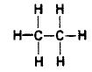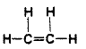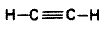

_______________________________ _______________________________ _______________________________

Carbohydrates: Carbohydrates are organic compounds composed of carbon, hydrogen, and oxygen. The proportion of hydrogen atoms to oxygen atoms in carbohydrates is the same as in water—two hydrogens to one oxygen. There are three basic types of carbohydrates: monosaccharides, disaccharides, and polysaccharides.

Monosaccharides: Monosaccharides, or simple sugars, are the least complicated carbohydrates. In biology the three most common simple sugars are glucose, galactose, and fructose. These three sugars all have the same chemical formula (C₆H₁₂0₆), but their atoms are arranged differently (see below).
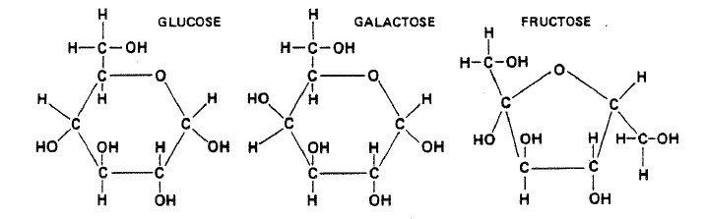
Questions:
- In what way do glucose and galactose differ from each other? Circle the parts of both compounds that show this difference.

- The chemical formula for all monosaccharides is _________________________________.

Dehydration Synthesis and Hydrolysis: Carbohydrates, proteins, and lipids are all synthesized and broken down by the same types of reactions. In dehydration synthesis, a hydrogen ion (H⁺) from one molecule joins with a hydroxyl group (OH⁻) from another molecule to form water (H₂O), leaving the two molecules bonded to the same oxygen atom. For example, when two molecules of glucose are joined by dehydration synthesis, they form maltose and water (see below).
In hydrolysis, complex organic molecules are broken down by the addition of the components of water - H+ and OH-. Both dehydration synthesis and hydrolysis require certain conditions of pH and temperature and the presence of particular enzymes.
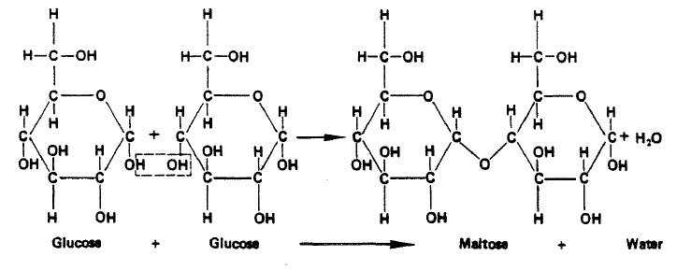
- In the space below, write the formula for the hydrolysis of maltose. (The reaction is the reverse of the dehydration synthesis of maltose.)

- What are the products of the hydrolysis of maltose?

- In what life process does hydrolysis occur?

Disaccharides: When two monosaccharides combine, they form a disaccharide. A disaccharide can consist either of two molecules of the same simple sugar combined or two different simple sugars combined. Some common disaccharides are maltose (or malt sugar), sucrose (or table sugar), and lactose (milk sugar). Maltose is made up of 2 glucose subunits. Sucrose is made up of glucose and fructose. Lactose is made up of glucose and galactose.

Questions:
- Name the monosaccharides that make up the following disaccharides:
  - maltose:
  - sucrose:
  - lactose:
- What is the chemical formula for maltose, sucrose, and lactose? (Hint: Disaccharides = (2 x monosaccharide) – H₂O)

- Why is the chemical formula for disaccharides not two times that of the monosaccharides?

- What are the common names for sucrose and lactose?
Polysaccharides and Polymers: The most complex carbohydrates are the polysaccharides, which are made up of long chains of monosaccharides (or glucose-like units). Starch, cellulose, and glycogen are polysaccharides. Large molecules made up of chains of repeating units are called polymers. Polysaccharides, such as the ones mentioned above are polymers.

Questions:
- What substance is the repeating unit that makes up starch, cellulose, and glycogen?

- Starch, cellulose, and glycogen are all made up of the same repeating unit. In what way do these three substances differ from one another?

- Name another type of compound (beside polysaccharides) that fits the definition of a polymer,

Lipids: Lipids are a group of organic compounds that include fats, oils, waxes, and related substances. Lipids are composed of carbon, hydrogen, and oxygen, but there is no definite ratio of hydrogen to oxygen atoms in lipids as there is in carbohydrates. Simple lipids, which are the most common type, are made up of three fatty acid (C_{n}H_{2n}COOH) molecules and one glycerol (C₃H₈O₃) molecule.

Questions:
- Label each of the components in the equation below.
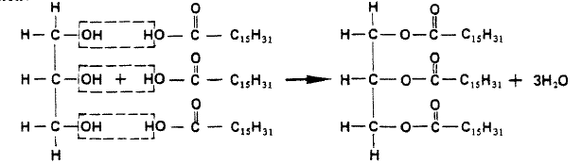

_________________________ _____________________________ ___________________________________ ____________

- What type of reaction is shown in the equation?

- What type of compound is glycerol?

- Write the chemical formula for fatty acids.

- What is the difference between a saturated and an unsaturated fatty acid?

Proteins: Proteins are the most abundant type of organic compound in cells. They are made up of many amino acid molecules bonded together. Proteins, which may be very large and complex, play a wide variety of roles in the cell. Some are structural, others are hormones, neurohumors, enzymes, or pigments.
Amino acids are made up of carbon, hydrogen, oxygen, and nitrogen; some also contain sulfur. Amino acids are bonded together to form proteins by dehydration synthesis. The type of bond formed between amino acids is called a peptide bond. It involves a carboxyl group from one molecule and an amino group from the other.

Questions:
- Name three foods that are high in protein.
- Below is the general formula for an amino acid. Circle the amino group and the carboxyl group.
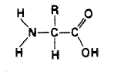
- Using the general formula for amino acids, in the space below show the formation of a peptide bond.

- What does the R represent in the general formula for amino acids?

Enzymes: Enzymes are proteins that act as catalysts in living cells. A catalyst increases the rate of a chemical reaction, allowing it to proceed rapidly when it would otherwise occur only very slowly. Enzymes are highly specific in their catalytic activity. The specificity of enzyme action is the result of a
"lock-and-key" arrangement in which the enzyme and the substance it reacts with (the substrate) join together at the active site to form an enzyme-substrate complex. When the reaction is completed, the enzyme and the newly formed reaction products separate, leaving the enzyme unchanged. Enzymes are highly efficient catalysts, and only small quantities are needed to catalyze the reaction of relatively large amounts of materials. Each enzyme has an optimum range of temperature and pH at which it operates most efficiently.

Questions:
- Is an enzyme "used up" by the reaction it catalyzes? Explain.

- In what way does an enzyme affect the reaction it catalyzes? How does the enzyme produce this effect?

- What is meant by enzyme specificity?

- What is the active site of an enzyme?

- The substance with which an enzyme reacts is its ______________________________.

- Could life as we know it exist without enzymes? Explain.
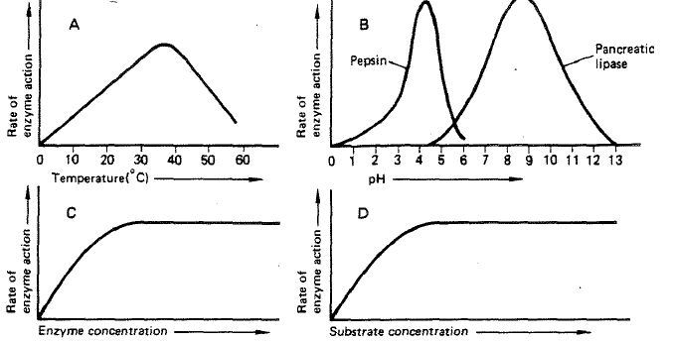
Questions 7-10 are based on the graphs above.
- According to graph A, at what temperature is enzyme activity the greatest?

- According to graph B, what is the optimum pH for pepsin? As pH increases above that point, what happens to enzyme activity?

- According to graph C, how does increasing enzyme concentration affect the rate of enzyme
action when the substrate concentration remains constant?

- According to graph D, how does increasing substrate concentration affect the rate of enzyme
action when enzyme concentration remains constant?

Nucleic Acids: There are two types of nucleic acids found in living organisms—DNA (deoxyribonucleic acid) and RNA (ribonucleic acid). Both are giant molecules of high molecular weight, consisting of a series of nucleotide units bonded together. Each nucleotide consists of a five-carbon sugar bonded to a nitrogen base and a phosphate group. DNA contains the hereditary information and is stored in the nucleus, while RNA functions in protein synthesis.

Questions:
- What are the three basic components of the nucleotides that make up nucleic acids?

- Where is DNA found in the cell?

- Describe the basic functions of DNA.

- Describe the basic functions of RNA.

Extension Questions:
- Metabolism is the collective term used to describe all the chemical reactions taking place inside living organisms. Why is water so important for metabolic reactions?

- We store excess food in our body either in the form of carbohydrates (in muscles and the liver) or as fat (adipose tissue). When our body needs additional energy it uses the carbohydrate source first as a source of “quick” energy, then the fat. Why do you think carbohydrates are used as a source of quick energy rather than fat? Use complete sentences and scientific terminology in your response.

- Look at the two types of fatty acids below, saturated and unsaturated. What is the difference between the two?
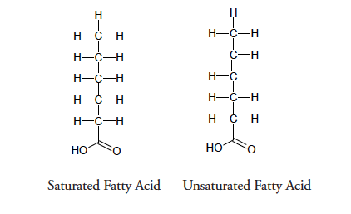

- Saturated fats are solid fats, like the animal fats lard and butter, whereas unsaturated fats are more fluid and form oils, such as vegetable oil. Trans fats are plant oils that are artificially solidified to make them suitable for baking purposes. In recent years trans fats have been associated with negative health issues and are not as widely used. Explain in simple molecular terms what would have to be done to a plant oil to transform it to a trans fat.

