Introduction:
We can learn a lot by looking at chromosomes! They can tell us everything from the likelihood that an unborn baby will have a genetic disorder to whether a person will be male or female. Scientists often analyze chromosomes in prenatal testing and in diagnosing specific diseases. Fetal cells from an unborn child are contained in the amniotic fluid and can be tested for hereditary disorders such as Tay-Sachs or Phenylketonuria. Chromosomes are compact spools of DNA. If you were to stretch out all the DNA from one of your cells, it would be over 3 feet (1 meter) long from end to end! You can think of chromosomes as "DNA packages" that enable all this DNA to fit in the nucleus of each cell. Normally, we have 46 of these packages in each cell; we received 23 from our mother and 23 from our father. A karyotype is an organized profile of a person’s chromosomes. In a karyotype, chromosomes are arranged and numbered by size, from largest to smallest. This arrangement helps scientists quickly identify chromosomal alterations that may result in a genetic disorder.
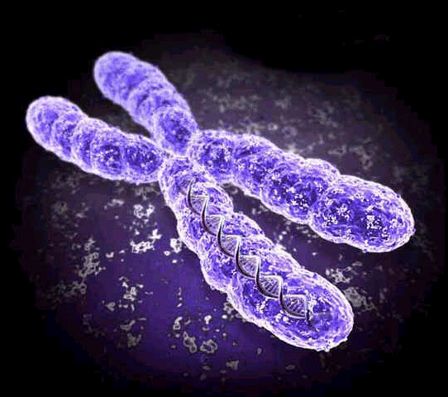
To make a karyotype, scientists take a picture of someone’s chromosomes, cut them out and match them up using size, banding pattern and centromere position as guides. Homologous pairs are arranged by size in descending order (largest to smallest) with the sex chromosomes (XX for female or XY for male) as the last or 23 pair.
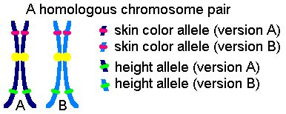
Homologous chromosomes have genes for the same trait at the same location. Since humans have 46 chromosomes in their somatic or body cells, they have 23 pairs of chromosomes in their karyotype. If chromosomes fail to separate in meiosis, a condition called nondisjunction, a person may have more or less than the normal 46 chromosomes on their karyotype. A disorder called Down Syndrome would be a example of this. A person with Down Syndrome will have 3 chromosomes in their 21st pair. The image below shows chromosomes as they are seen on the slide (left panel) and after arrangement (right panel).

Procedure:
- Use your assigned sex and chromosome condition to determine how many of each chromosome you will need for your karyotype. (Assigned conditions include Normal male, Normal female, Female with Turner Syndrome, Male with Klinefelter’s Syndrome, Female with Down Syndrome, Male with Down Syndrome, Female with three X chromosomes, Male with no X chromosome, female with Cri-du-chat, Male with Cri-du-chat)
- Cut out this number of chromosomes keeping the homologous pairs together. (Do not cut off the chromosome numbers until you are ready to glue the chromosomes to your karyotype sheet.)
- Start arranging the chromosome pairs on the construction paper karyotype sheet in descending order by their size. Do not glue the chromosomes until all of them are arranged correctly.
- Evenly space out 4 rows of chromosomes on your karyotype sheet. Row 1 should contain pairs 1-6, row 2 has pairs 7-12, row 3 has pairs 13-18, and row 4 pairs 19 through the sex chromosomes.
- If any additional chromosomes are needed to complete your karyotype, cut these out from additional chromosome sheets.
- Make sure ALL PAIRS are in the same direction with their SHORTER END TOWARDS THE TOP OF THE CONSTRUCTION PAPER.
- Cut off the numbers from one homologous pair of chromosomes at a time and glue that pair to your construction paper karyotype sheet.
- With your ink pen or marker, neatly number each pair 1-23 below the glued pair.
- In the lower left corner of your karyotype, write the sex of your individual and their genetic condition (normal, Cri-du-chat, Down’s…).
- In the lower right corner, write the total number of chromosomes for this person.

karyotype template
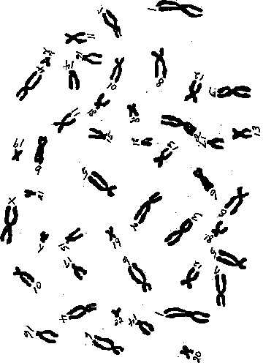
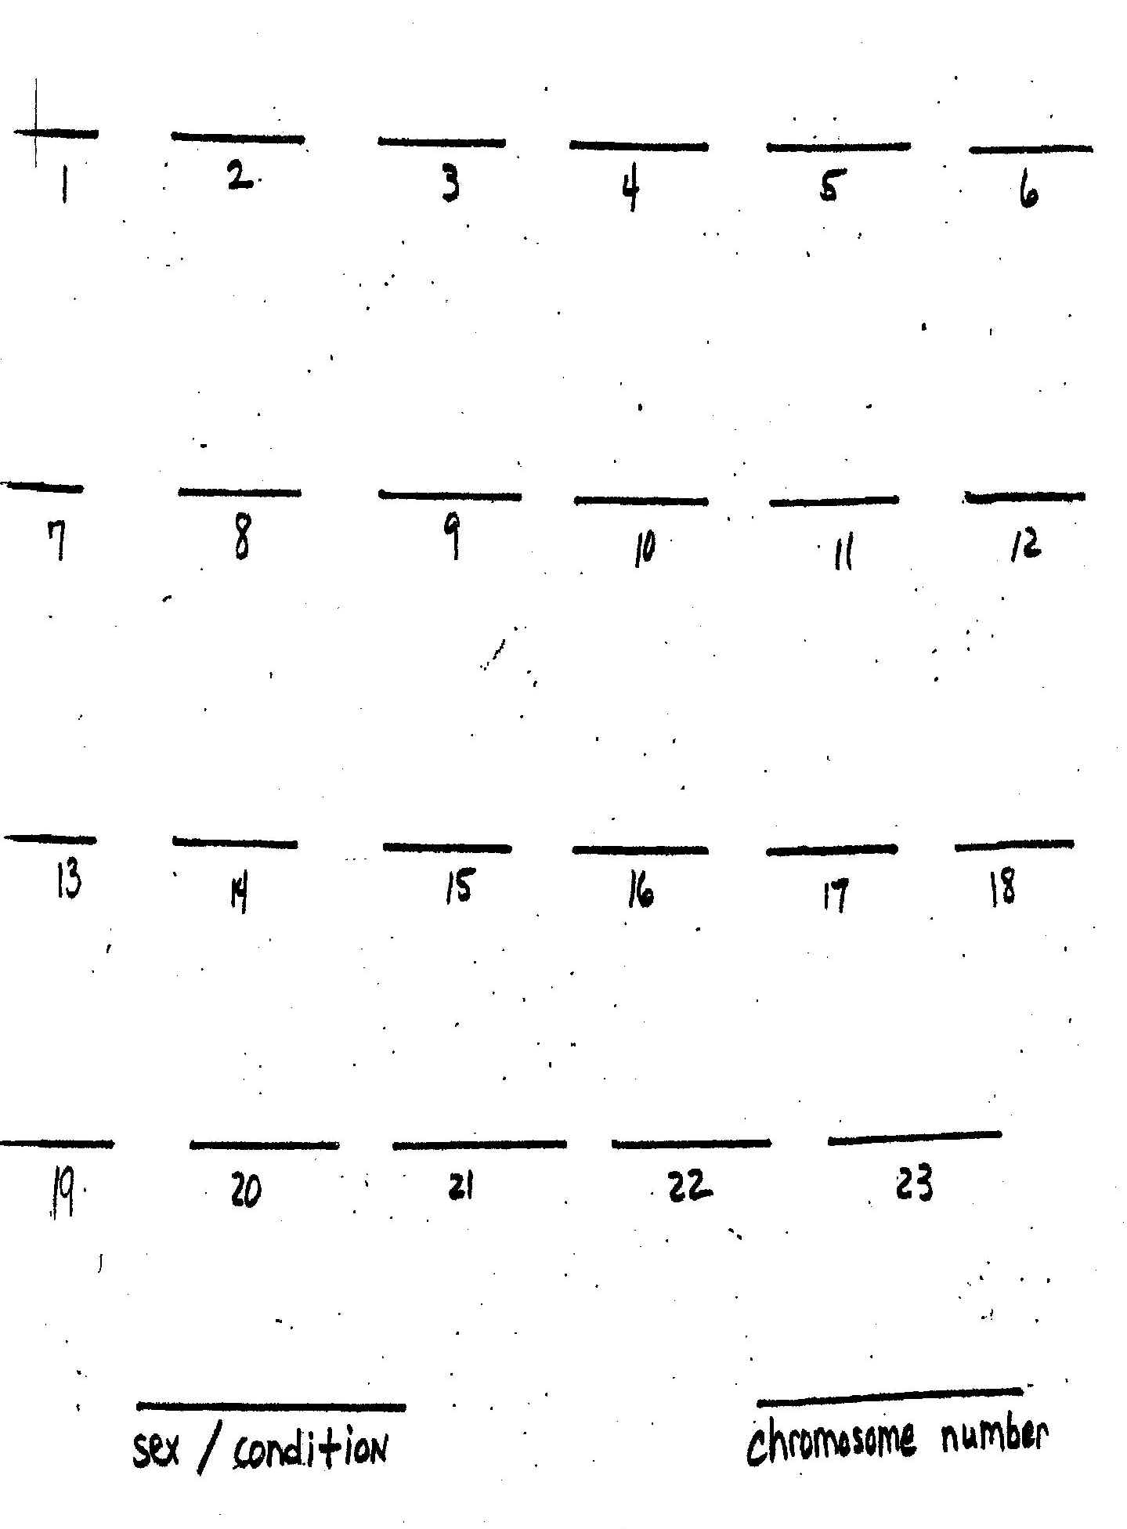
Questions & Observations:
- What is a karyotype?
2. How can a karyotype be useful to a couple wanting to have children?
3. What makes up chromosomes?
4. What was the sex of the individual you were assigned?
5. What is this person’s GENOTYPE for sex?
6. What is a mutation?
7. What mutation, if any, occurred in this person’s karyotype?
8. How many chromosomes are in a somatic or body cell of this individual?
9. How many chromosomes are in a gamete or sex cell of this individual?
10. How many chromosomes are in a normal person’s somatic cells?
11. How many chromosomes are in a normal person’s gametes?
12. How many UNPAIRED chromosomes are there in this organism’s somatic cells?
13. What is the sex of an individual with 23 MATCHED pairs of chromosomes?
14. What is the diploid number for this organism?
15. Explain nondisjunction.

16. Name and explain 3 disorders due to nondisjunction of chromosomes.

