Exit Slip: Tonicity Name: _____________________

Block:______________________

1. Label each picture as hypotonic, hypertonic or isotonic.
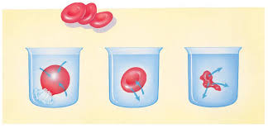

__________ __________ ___________

2. What is the diffusion of water called? Is it passive transport or active transport?

3. Why does a slug shrivel up when you pour salt on it?

Exit Slip: Tonicity Name: _____________________

Block:______________________

1. Label each picture as hypotonic, hypertonic or isotonic.

__________ __________ ___________

2. What is the diffusion of water called? Is it passive transport or active transport?

3. Why does a slug shrivel up when you pour salt on it?

