Station 1: Spontaneous Generation:
Explain how each contributed to our understanding of Spontaneous generation:
 | Pro or Con | Summarize their experiment
Redi
Needham
Spallanzani
Pasteur

Station 2: What is the difference between “survival of the fittest” and “natural selection”?
Watch the video (https://www.youtube.com/watch?v=jHQcKUJGZSM ) and explain how organisms can evolve without competition.

Station 3: Watch the video and analyze the diagrams provided to explain the difference between Lamarck and Darwin in the evolution of the giraffe. (https://www.youtube.com/watch?v=JSk89My2Y7o)

Station 4: Define Species:

Are mules technically a species?

Watch the video “Speciation” (https://www.youtube.com/watch?v=Q2vsG77PZ80 ) and explain how how or why species can change (your explanation must use the term adaptive radiation)

Station 5: Watch the video about Types of Natural Selection (https://www.youtube.com/watch?v=64JUJdZdDQo )
What are examples of environmental pressures that cause species to change?
 | Sketch | How does species change?
Directional
Stabilizing
Disruptive

Station 6: Winging It
Compare the bones in a chicken wing to the arm and hand of a human skeleton.

1. What are the similarities and differences?

2. Where are the scapula, humerus, radius, and ulna bones of each?

3. Look at the pictures of other vertebrate forelimbs (bats, dogs, etc.). How does the function of the chicken, human, and other vertebrate forelimbs differ?

4. How might natural selection account for the development of different uses for limbs in different species?

Station 7: Skull Comparisons (Comparative Anatomy)
1. Explain three ways how the skulls are similar.

2. Explain two ways that the skulls differ (other than size)
3. Which two have the most similar teeth? Why do you think this is so?

4. Of these animals, which two do you think are more closely related? Explain your reasoning.

5. How can you relate natural selection to the differences in these skulls?

Station 8: Cladograms (https://www.youtube.com/watch?v=46L_2RI1k3k )
How do cladograms group organisms?

How are they like family trees that show speciation?

Make a cladogram for the following organisms on the key below: humans, shark, kangaroo, bullfrog

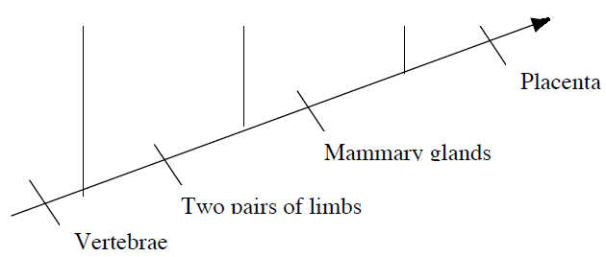

Make a cladogram for the animals in station 7 based on the skull characteristic

Station 9: Timing Is Everything (Embryology)
1. Fill in the chart with the pictures. When done, copy the letters down in the chart below.
 | Fish | Chick | Pig | Calf | Human
Stage 1
Stage 2
Stage 3

2. When you are done, write a brief explanation of why you ordered the drawings the way you did.

3. What similarities do the drawings have? What differences?
4. What, if any, trends do you see as you go from stage 1 to stage 3?
5. How can DNA account for the trends you noted?

Station 10: Karyotyping Species (Biochemical Connections)
Complete the following tally sheet. For each chromosome put a check mark beside the one species which best matches the human.
Chromosome | A | B | C | Chromosome | A | B | C | Chromosome | A | B | C | Chromosome | A | B | C
1 |  |  |  | 7 |  |  |  | 13 |  |  |  | 18
2 |  |  |  | 8 |  |  |  | 14 |  |  |  | 19
3 |  |  |  | 9 |  |  |  | 15 |  |  |  | 20
4 |  |  |  | 10 |  |  |  | 16 |  |  |  | 21
5 |  |  |  | 11 |  |  |  | 17 |  |  |  | 22
6 |  |  |  | 12 |  |  |  | X |  |  |  | Y

1. There is one somatic (non-sex) chromosome that is virtually identical in banding patterns (except for the tips) between the humans and three species? Which is it?
2. Which chromosome set is the most different from humans? What makes you pick this one?
3. Overall, would you say that there are more similarities or more differences between the two sets of chromosomes? Give reasons for your answer.
4. Which of these species is most closely related to humans? What is the physical evidence supporting your conclusion?

Station 11: When An Apple A Day Isn’t Enough (Video)
Watch the video segments “Double Immunity”.
http://www.pbs.org/wgbh/evolution/library/10/4/l_104_05.html

1. How does an understanding of evolution help doctors manage infectious diseases?
2. What factors affect the evolution of disease organisms to make them become more virulent?
3. What is the relationship between HIV resistance and the Black Death?

4. How have disease organisms coevolved with humans?

Station 6

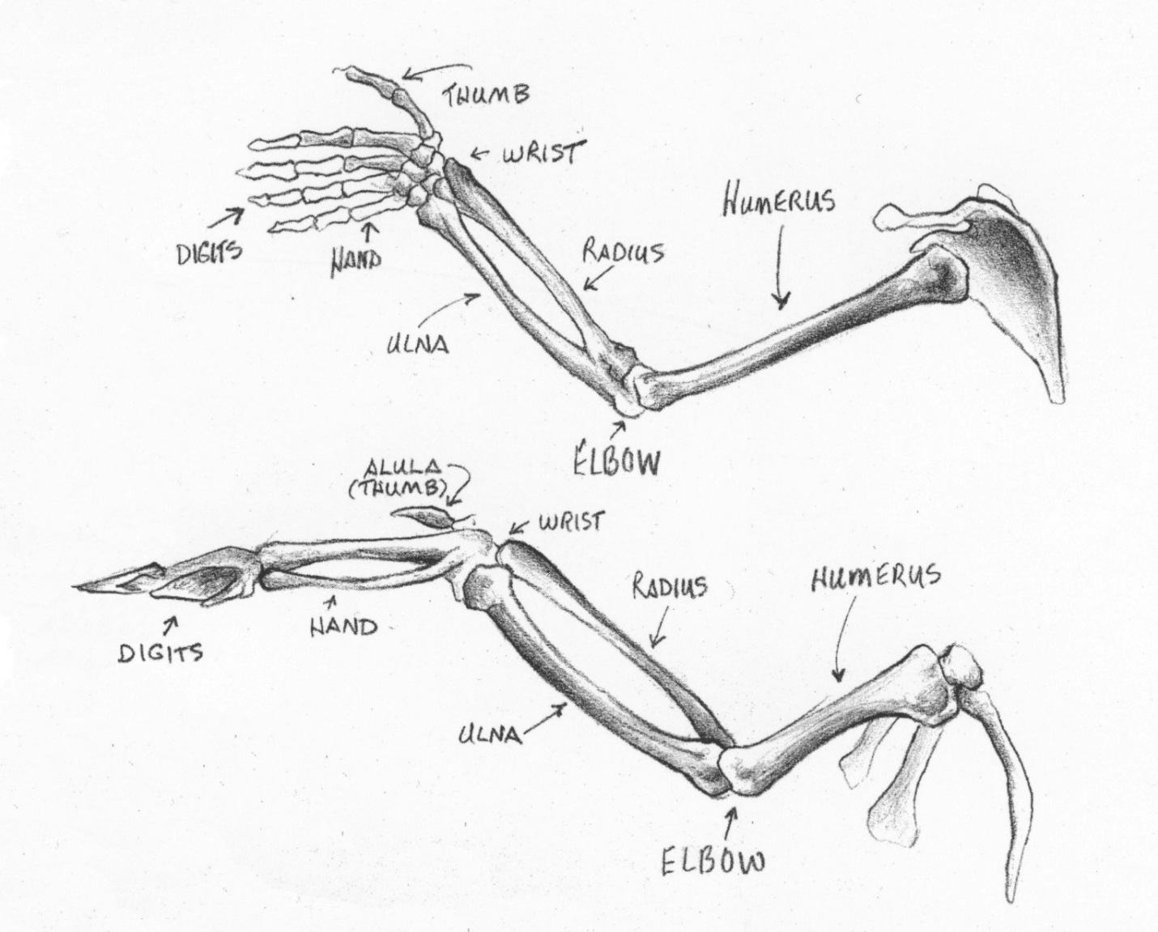
Station 7: Skull Comparisons (Comparative Anatomy)
Skulls can be used for evolution comparisons. Carefully observe the skulls on the table and compare the following parts:
• Orbit: eyesocket
• Naris (pl. nares): nostril
• Antorbital fenestra: an opening in the facial bones of dinosaurs and their relatives, between the nostrils and the eyesocket.
• Teeth. In dinosaurs and most other land-dwelling vertebrates, the teeth are found in three main bones: two on each side of the upper jaw, and one on each side of the lower jaw

Station 10: Karyotyping Species (Biochemical Connections)
Chromosomes are microscopic strands found in the nuclei of the cells of living things. As you may have learned in genetics, the codes for an organism’s characteristics are located on that organism’s chromosomes. Comparison of chromosomes is one of the ways currently being used to determine the evolutionary relationships between organisms of different species. Organisms get their chromosomes from their parents, and even further back in time, from their ancestors. The theory of evolution predicts that two species having a recent common ancestor should have chromosomes that are more similar than two species having a common ancestor further back in time. In other words, species that are more closely related should have more similar chromosomes.

It is possible to directly compare the chromosomes of two species of organisms. This is done by obtaining and staining a cell from a member of each of the two species. The chromosomes in the cells are located using a microscope. Then, a special camera that attaches to the microscope is used to take a picture. This picture is called a karyotype.

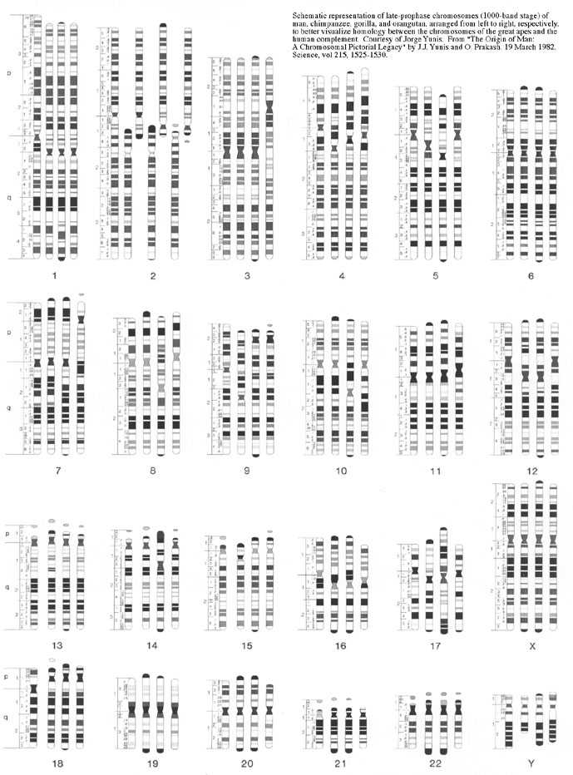
Each set of chromosomes represent a human and 3 other animals. The human is always the first in each set followed by animal A, B, and C. No other clues are given so you must base conclusion on DNA presented here.

