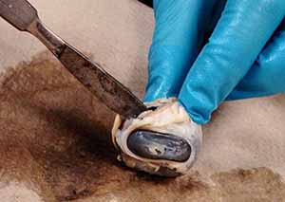
COW EYE DISSECTION
1. Examine the outside of the eye. You should be able to find the sclera, or the whites of the eye. This tough, outer covering of the eyeball has fat and muscle attached to it
2. Locate the covering over the front of the eye, the cornea. When the cow was alive, the cornea was clear. In your cow’s eye, the cornea may be cloudy or blue in color.
2. Cut away the fat and muscle, this may only be necessary if fat is covering the cornea of the eye and is in your way. Fat around the backside of the eye can be left alone. Flip the eye over to find the optic nerve where it exits out the back of the eye. It will be stronger and more rope-like than the surrounding fat tissue.
4. Use a scalpel or scissors to make an incision in the cornea. The cornea is tougher than it appears and may require some force to puncture, be careful when using the scalpel. Once the cornea is broken, clear liquid will leak (or squirt) out – this liquid is the aqueous humor.
5. Quick Check: Outer Tunic
A. The white of the eye is the ________________
B. The front surface of the eye, continuous with (A) is the __________________
C. The liquid found in the front of the eye is the ________________________
D. What is the name of the nerve found on the back of the eye? ______________________
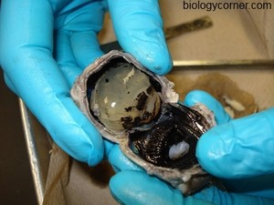
6. Use a scalpel or scissors to make an incision in the sclera so that you can cut around the outside of the eye. Your goal is to separate the eye into a front and a back half.
7. Separate the inner parts of the eye.
The gelatinous liquid in the middle of the eye is the vitreous humor , which will also contain a hard, sphere-shaped lens.
Find the cornea (which you punctured in step 1) and then the disk-shaped iris behind it.
The iris will be dark in color and contain a center opening, the pupil.
8. The image below shows how each part of the eye appears when it has been separated. Take a photo of your own eye and share it on social media. #coweye (optional)
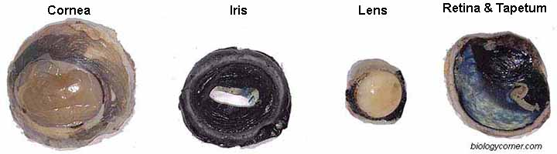
9. The back of the eye has two layers, a very thin layer of cells that is easy to scrape off (and may fall off on its own), which is the retina . Behind, the retina is a blue, reflective layer known as the tapetum.
10. The retina will converge at a point on the eye where it connects with the optic nerve. This is the optic disk. It may be easiest to find by scraping off the retina and locating the spot where it remains closely attached. Flipping the eye over will also show how that spot is directly in front of the optic nerve.

Tell three observations you made when you examined the surface of the eye:
- ______________________________
- ______________________________
- ______________________________
2. Identify the following structures:
- cornea
- tear gland-
- optic nerve
- iris-
- pupil-
- retina
Name the three layers you sliced through when you cut across the top of the eye:
- ______________________________
- ______________________________
- ______________________________

Match the following parts of the eye to their function: (ciliary body, sclera, iris, retina, lens, & tapetum lucidum)
____________________ Contains the photoreceptors for vision.
____________________ The colored portion of the eye.
____________________ This structure changes shape to focus light on the retina.
____________________ The opening in the iris through which light passes.
____________________ The iridescent portion of the choroid layer in nocturnal animals.
____________________Consists of muscles, which control and shape the lens.
____________________ The white of the eye.
4. Use the pictures below to name the parts of the eye:

 
 
 
 
 
 
 
 
 
 
 
 

