Classification using 3 point paragraph Name: ______________________________

You will be determining the Kingdom of an organism based on a provided image. You must justify your answer by writing a three-point paragraph. You will then be assigned to a small group who share the same kingdom as your organism where you will compare and contrast your paragraphs to the key characteristics and revise the paragraph if needed.

Three-Point Paragraph Outline:
Topic Sentence
First point Sentence
Supporting details for first point
Second point sentence
Supporting details for second point
Third point Sentence
Supporting details for third point
Conclusion

Organism: Salmonella

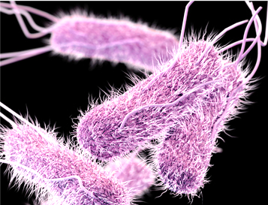
Strains of Salmonella cause illnesses such as typhoid fever and food poisoning. Salmonella species have flagella and are mobile. They obtain their energy from organic sources and are capable of surviving with or without oxygen.

Classification using 3 point paragraph Name: ______________________________

You will be determining the Kingdom of an organism based on a provided image. You must justify your answer by writing a three-point paragraph. You will then be assigned to a small group who share the same kingdom as your organism where you will compare and contrast your paragraphs to the key characteristics and revise the paragraph if needed.

Three-Point Paragraph Outline:
Topic Sentence
First point Sentence
Supporting details for first point
Second point sentence
Supporting details for second point
Third point Sentence
Supporting details for third point
Conclusion

Organism: Escherichia coli
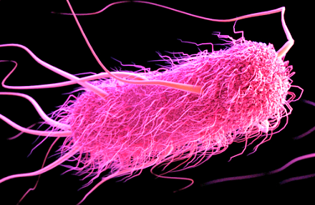
E. coli are commonly found in the lower intestine of warm-blooded organisms. Most are harmless, but some can cause serious food poisoning if ingested. E. coli can live on a wide variety of organic sources and can survive in anaerobic conditions.

Classification using 3 point paragraph Name: ______________________________

You will be determining the Kingdom of an organism based on a provided image. You must justify your answer by writing a three-point paragraph. You will then be assigned to a small group who share the same kingdom as your organism where you will compare and contrast your paragraphs to the key characteristics and revise the paragraph if needed.

Three-Point Paragraph Outline:
Topic Sentence
First point Sentence
Supporting details for first point
Second point sentence
Supporting details for second point
Third point Sentence
Supporting details for third point
Conclusion

Organism: Chlamydiae

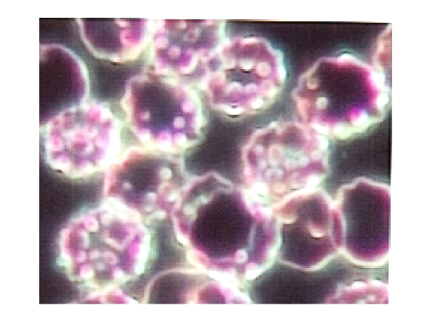
All known chlamydiae are pathogens that only grow by infecting eukaryotic host cells. They are unicellular and do not have a nucleus.

Classification using 3 point paragraph Name: ______________________________

You will be determining the Kingdom of an organism based on a provided image. You must justify your answer by writing a three-point paragraph. You will then be assigned to a small group who share the same kingdom as your organism where you will compare and contrast your paragraphs to the key characteristics and revise the paragraph if needed.

Three-Point Paragraph Outline:
Topic Sentence
First point Sentence
Supporting details for first point
Second point sentence
Supporting details for second point
Third point Sentence
Supporting details for third point
Conclusion

Organism: Methanogen

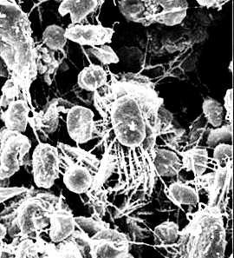
Methanogens are unicellular organisms without a nucleus that produce methane as a byproduct in low oxygen conditions. Some are extremophiles, found in environments such as hot springs and submarine hydrothermal vents as well as in the "solid" rock of the Earth's crust, kilometers below the surface.

Classification using 3 point paragraph Name: ______________________________

You will be determining the Kingdom of an organism based on a provided image. You must justify your answer by writing a three-point paragraph. You will then be assigned to a small group who share the same kingdom as your organism where you will compare and contrast your paragraphs to the key characteristics and revise the paragraph if needed.

Three-Point Paragraph Outline:
Topic Sentence
First point Sentence
Supporting details for first point
Second point sentence
Supporting details for second point
Third point Sentence
Supporting details for third point
Conclusion

Organism: Halobacteria

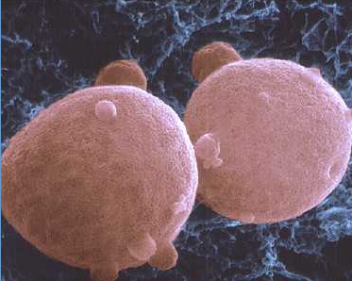
This unicellular organism does not have a nucleus and can survive only in extremely high salinity lakes and brine ponds. They produce their own energy and can grow aerobically or anaerobically.

Classification using 3 point paragraph Name: ______________________________

You will be determining the Kingdom of an organism based on a provided image. You must justify your answer by writing a three-point paragraph. You will then be assigned to a small group who share the same kingdom as your organism where you will compare and contrast your paragraphs to the key characteristics and revise the paragraph if needed.

Three-Point Paragraph Outline:
Topic Sentence
First point Sentence
Supporting details for first point
Second point sentence
Supporting details for second point
Third point Sentence
Supporting details for third point
Conclusion

Organism: Jellyfish
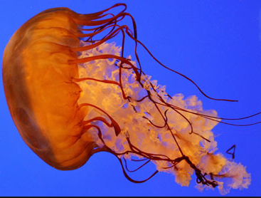
Jellyfish are free-swimming marine animals consisting of a gelatinous umbrella-shaped bell and trailing tentacles. The bell can pulsate for locomotion, while stinging tentacles can be used to capture prey.

Classification using 3 point paragraph Name: ______________________________

You will be determining the Kingdom of an organism based on a provided image. You must justify your answer by writing a three-point paragraph. You will then be assigned to a small group who share the same kingdom as your organism where you will compare and contrast your paragraphs to the key characteristics and revise the paragraph if needed.

Three-Point Paragraph Outline:
Topic Sentence
First point Sentence
Supporting details for first point
Second point sentence
Supporting details for second point
Third point Sentence
Supporting details for third point
Conclusion

Organism: Ant

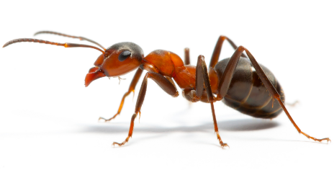
Ants are found on all continents except Antarctica, and only a few large islands, lack native ant species. Ants exploit many different food resources as direct or indirect herbivores, predators and scavengers.

Classification using 3 point paragraph Name: ______________________________

You will be determining the Kingdom of an organism based on a provided image. You must justify your answer by writing a three-point paragraph. You will then be assigned to a small group who share the same kingdom as your organism where you will compare and contrast your paragraphs to the key characteristics and revise the paragraph if needed.

Three-Point Paragraph Outline:
Topic Sentence
First point Sentence
Supporting details for first point
Second point sentence
Supporting details for second point
Third point Sentence
Supporting details for third point
Conclusion

Organism: Salamander

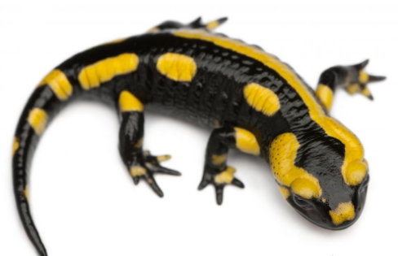
Salamanders are typically characterized by a lizard-like appearance, with slender bodies, blunt snouts, short limbs projecting at right angles to the body, and the presence of a tail. They are opportunistic predators.

Classification using 3 point paragraph Name: ______________________________

You will be determining the Kingdom of an organism based on a provided image. You must justify your answer by writing a three-point paragraph. You will then be assigned to a small group who share the same kingdom as your organism where you will compare and contrast your paragraphs to the key characteristics and revise the paragraph if needed.

Three-Point Paragraph Outline:
Topic Sentence
First point Sentence
Supporting details for first point
Second point sentence
Supporting details for second point
Third point Sentence
Supporting details for third point
Conclusion

Organism: Great White Shark

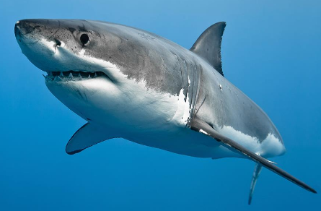
The great white shark is notable for its size, with mature female individuals growing up to 20 ft in length and 4,300 lb in weight. Sharks have a cartilaginous skeleton, five to seven gill slits on the sides of the head, and pectoral fins that are not fused to the head. The great white shark is arguably one of the primary predators of marine mammals.

Classification using 3 point paragraph Name: ______________________________

You will be determining the Kingdom of an organism based on a provided image. You must justify your answer by writing a three-point paragraph. You will then be assigned to a small group who share the same kingdom as your organism where you will compare and contrast your paragraphs to the key characteristics and revise the paragraph if needed.

Three-Point Paragraph Outline:
Topic Sentence
First point Sentence
Supporting details for first point
Second point sentence
Supporting details for second point
Third point Sentence
Supporting details for third point
Conclusion

Organism: Earthworm
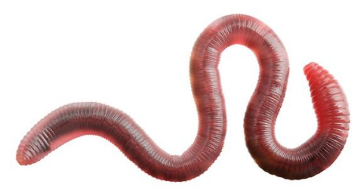
Earthworms are commonly found living in soil, feeding on live and dead organic matter. An earthworm's digestive system runs through the length of its body. Earthworms are hermaphrodites—each individual carries both male and female sex organs. They lack either an internal skeleton or exoskeleton, but maintain their structure with fluid-filled coelom chambers.

Classification using 3 point paragraph Name: ______________________________

You will be determining the Kingdom of an organism based on a provided image. You must justify your answer by writing a three-point paragraph. You will then be assigned to a small group who share the same kingdom as your organism where you will compare and contrast your paragraphs to the key characteristics and revise the paragraph if needed.

Three-Point Paragraph Outline:
Topic Sentence
First point Sentence
Supporting details for first point
Second point sentence
Supporting details for second point
Third point Sentence
Supporting details for third point
Conclusion

Organism: Giardia

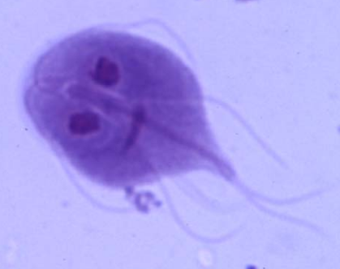
Giardia is a parasite that lives in the intestines of infected animals. They colonize and reproduce in the small intestines of several vertebrates. Giardia have two nuclei, each with four associated flagella, and were thought to lack both mitochondria and a Golgi apparatus.

Classification using 3 point paragraph Name: ______________________________

You will be determining the Kingdom of an organism based on a provided image. You must justify your answer by writing a three-point paragraph. You will then be assigned to a small group who share the same kingdom as your organism where you will compare and contrast your paragraphs to the key characteristics and revise the paragraph if needed.

Three-Point Paragraph Outline:
Topic Sentence
First point Sentence
Supporting details for first point
Second point sentence
Supporting details for second point
Third point Sentence
Supporting details for third point
Conclusion

Organism: Paramecium

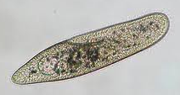
Paramecium are unicellular ciliated protozoan that have a nucleus. They feed on microorganisms like bacteria, algae, and yeasts. Paramecia propel themselves by whiplash movements of their cilia, which are arranged in tightly spaced rows around the outside of their body.

Classification using 3 point paragraph Name: ______________________________

You will be determining the Kingdom of an organism based on a provided image. You must justify your answer by writing a three-point paragraph. You will then be assigned to a small group who share the same kingdom as your organism where you will compare and contrast your paragraphs to the key characteristics and revise the paragraph if needed.

Three-Point Paragraph Outline:
Topic Sentence
First point Sentence
Supporting details for first point
Second point sentence
Supporting details for second point
Third point Sentence
Supporting details for third point
Conclusion

Organism: Euglena

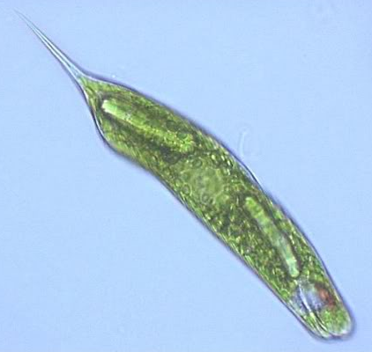
Euglena are single-celled organism with a nucleus and flagella found in fresh and salt waters. Most species of Euglena have photosynthesizing chloroplasts within the body of the cell. However, they can also take nourishment by eating.

Classification using 3 point paragraph Name: ______________________________

You will be determining the Kingdom of an organism based on a provided image. You must justify your answer by writing a three-point paragraph. You will then be assigned to a small group who share the same kingdom as your organism where you will compare and contrast your paragraphs to the key characteristics and revise the paragraph if needed.

Three-Point Paragraph Outline:
Topic Sentence
First point Sentence
Supporting details for first point
Second point sentence
Supporting details for second point
Third point Sentence
Supporting details for third point
Conclusion

Organism: Amoeba
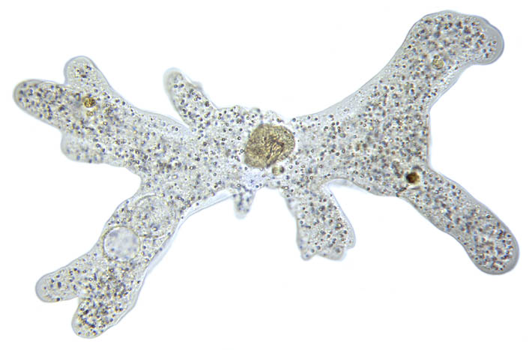
Amoeba are unicellular organisms that have a nucleus and move through extensions of their cytoplasm. The food sources of amoebae vary. Some amoebae are predatory and live by consuming bacteria and other protists. Some are detritivores and eat dead organic material.

Classification using 3 point paragraph Name: ______________________________

You will be determining the Kingdom of an organism based on a provided image. You must justify your answer by writing a three-point paragraph. You will then be assigned to a small group who share the same kingdom as your organism where you will compare and contrast your paragraphs to the key characteristics and revise the paragraph if needed.

Three-Point Paragraph Outline:
Topic Sentence
First point Sentence
Supporting details for first point
Second point sentence
Supporting details for second point
Third point Sentence
Supporting details for third point
Conclusion

Organism: Fern

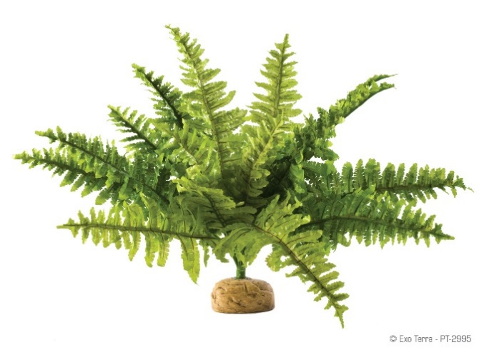
A fern is a multicellular vascular organism that does not have seeds nor flowers. They have branched stems and leaves. Most ferns have what are called fiddleheads that expand into fronds, which are each delicately divided and contain chloroplast for photosynthesis.

Classification using 3 point paragraph Name: ______________________________

You will be determining the Kingdom of an organism based on a provided image. You must justify your answer by writing a three-point paragraph. You will then be assigned to a small group who share the same kingdom as your organism where you will compare and contrast your paragraphs to the key characteristics and revise the paragraph if needed.

Three-Point Paragraph Outline:
Topic Sentence
First point Sentence
Supporting details for first point
Second point sentence
Supporting details for second point
Third point Sentence
Supporting details for third point
Conclusion

Organism: Conifer
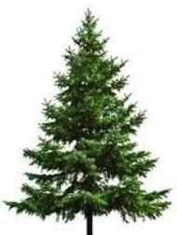
Conifers are organisms that produce a single woody trunk with branches where modified leaves are found. The leaves of many conifers are long, thin and have a needle-like appearance and contain chlorophyll for photosynthesis.

Classification using 3 point paragraph Name: ______________________________

You will be determining the Kingdom of an organism based on a provided image. You must justify your answer by writing a three-point paragraph. You will then be assigned to a small group who share the same kingdom as your organism where you will compare and contrast your paragraphs to the key characteristics and revise the paragraph if needed.

Three-Point Paragraph Outline:
Topic Sentence
First point Sentence
Supporting details for first point
Second point sentence
Supporting details for second point
Third point Sentence
Supporting details for third point
Conclusion

Organism: Mushroom

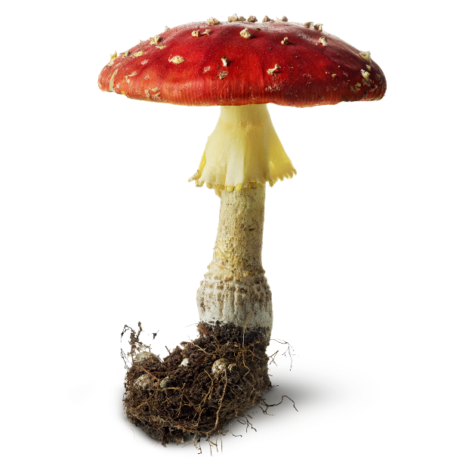
A mushroom is a multicellular organism that has cell walls made of chitin. It feeds off of decaying matter using structures called hyphae that resemble roots.

Classification using 3 point paragraph Name: ______________________________

You will be determining the Kingdom of an organism based on a provided image. You must justify your answer by writing a three-point paragraph. You will then be assigned to a small group who share the same kingdom as your organism where you will compare and contrast your paragraphs to the key characteristics and revise the paragraph if needed.

Three-Point Paragraph Outline:
Topic Sentence
First point Sentence
Supporting details for first point
Second point sentence
Supporting details for second point
Third point Sentence
Supporting details for third point
Conclusion

Organism: Polypores
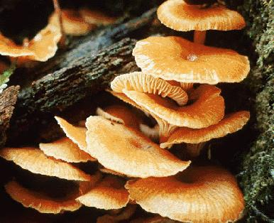
Polypores are multicellular organisms that inhabit tree trunks or branches consuming the wood and are among the most important agents of wood decay. They play a very significant role in nutrient cycling and carbon dioxide production of forest ecosystems.

Classification using 3 point paragraph Name: ______________________________

You will be determining the Kingdom of an organism based on a provided image. You must justify your answer by writing a three-point paragraph. You will then be assigned to a small group who share the same kingdom as your organism where you will compare and contrast your paragraphs to the key characteristics and revise the paragraph if needed.

Three-Point Paragraph Outline:
Topic Sentence
First point Sentence
Supporting details for first point
Second point sentence
Supporting details for second point
Third point Sentence
Supporting details for third point
Conclusion

Organism: Yeast

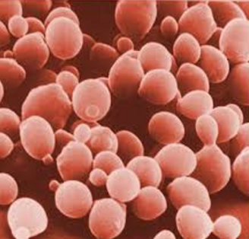
Yeasts are unicellular organisms with a nucleus. They are chemoorganotrophs, as they use organic compounds they eat as a source of energy and do not require sunlight to grow. Carbon is obtained mostly from sugars. Yeast species either require oxygen for aerobic cellular respiration or are anaerobic.

Classification using 3 point paragraph Name: ______________________________

You will be determining the Kingdom of an organism based on a provided image. You must justify your answer by writing a three-point paragraph. You will then be assigned to a small group who share the same kingdom as your organism where you will compare and contrast your paragraphs to the key characteristics and revise the paragraph if needed.

Three-Point Paragraph Outline:
Topic Sentence
First point Sentence
Supporting details for first point
Second point sentence
Supporting details for second point
Third point Sentence
Supporting details for third point
Conclusion

Organism: Corn
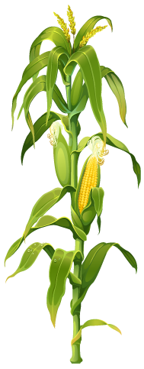

Corn is multicellular and have nuclei. The leafy stalk of corn produces separate pollen and fruits (ears). The leaves and husks contain chlorophyll and are the primary sites of photosynthesis. Sugar produced from photosynthesis is saved as starch within the kernels.

