Unit 1: Classification and Taxonomy Study Guide
- What classifies something under the animal kingdom?

- What are the 8 characteristics of living things?

- What are the two domains and what are the differences between them?

- What is homeostasis? Give one example.

- What are the 4 kingdoms of Eukarya?

- What are the 2 kingdoms of Prokarya?

- What are the Invertebrate phyla of the Animal kingdom? Give at least one example of each and list the defining characteristics of each.

- What are the groups in the vertebrate phyla of the Animal kingdom? Give at least one example of each and list the defining characteristics of each.

- What are the 4 plant phyla? Give one example of each and list the defining characteristics of each.

- What is binomial nomenclature? What two classification levels does it identify?

- What are the 7 levels of classification in order from most inclusive to least inclusive?

- What is a dichotomous key? How do we use them?

Name_______________________
Block_________________

- What are the differences between a plant and animal cell?

- What do ribosomes do?

- What is the function of mitochondria?

- What are the characteristics of bacteria?

- What are the characteristics of fungi?

- Use the dichotomous key below to identify each fish

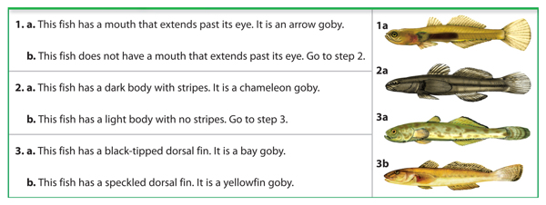

ANSWERS:
- Not being able to perform photosynthesis—being mobile, ingesting food, multicellular
- The 8 characteristics of living things are:
- All living things are made up of cells
- All living things maintain homeostasis
- All living things grow and develop
- All living things contain DNA
- All living things reproduce
- All living things adapt or evolve
- All living things obtain/use energy
- All living things respond to a stimulus
- The two domains are prokarya and eukarya. The main differences between the two is that prokarya do not have a membrane bound nucleus, have free floating DNA and are unicellular. Eukarya do have a membrane bound nucleus that contains DNA and can be unicellular and multicellular.
- Homeostasis is the process of our bodies maintaining a stable internal environment. An example of this is a dog panting after running.
- The 4 kingdoms of Eukarya are: Animalia, Plantae, Fungi and Protista.
- The 2 kingdoms of Prokarya are: Eubacteria and Archaebacteria
- The invertebrate phyla are:
  - Porifera: “pore bearing”, asymmetrical, no true tissues or organs, example is a sponge
  - Cnidaria: polyp form (tube like), radial symmetry, two-way gut, example is a jellyfish or coral
  - Platyhelminthes: unsegmented body, bilateral symmetry, two-way gut, example is a flatworm
  - Annelida: segmented body, bilateral symmetry, one-way gut, examples is an earthworm or segmented worm
  - Mollusca: bilateral symmetry, one-way gut, soft body with hard shell covering, examples include snails, slugs, and squid
  - Arthropoda: bilateral symmetry, segmented body, exoskeleton made of chitin, examples include shrimp, crabs and insects
  - Echinodermata: “spiny skin”, exclusively marine organisms, radial symmetry, examples include sea star, sand dollar and starfish
  - Chordata: possess a spinal cord or notocord, examples include humans, fish, birds
- The classes in the vertebrate phyla are:
  - MARK OUT!
- The 4 plant phyla are:
  - Bryophyta: non-vascular, no stems or roots, example is moss
  - Filicinophyta: vascular, land plants, example is a fern
  - Gymnosperms: also called conifers, produce seeds and cones, land dwelling, example is a douglas fir (Christmas tree)
  - Angiosperms: vascular, produce seeds, flowers and fruit, example is an oak tree
- Binomial nomenclature is the naming system developed by Carl Linneaus. It names the genus first and then species second. The genus name is always capitalized and the species name isn’t. Example: Homo sapien.
- Kingdom, Phylum, Class, Order, Family, Genus, Species
- A dichotomous key is a tool used to classify organisms based on their similar characteristics.
- A plant cell contains a cell wall, chloroplasts, and a large vacuole.
- Ribosomes make proteins
- Perform cellular respiration to make ATP/energy
- Bacteria are single-celled, prokaryotic cells, with no nucleus
- Fungi are decomposers, multicellular, plant-like organisms that cannot perform photosyntnesis
- Dichotomous key answers:
1a: Arrow Goby
2a: Chameleon Goby
3a: Bay Goby
3b: Yellowfin Goby

