Banana Ripeness Amyloplast Lab Learning Check
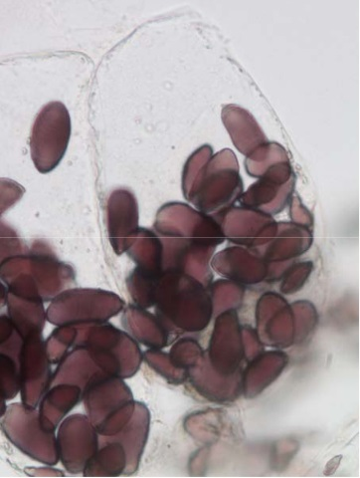

1. The image at right should look familiar to what you saw in the
microscope last class. What substance is stored in the dark
amyloplasts within the cell?
____________________________________(1)

2. What chemical was used to stain these structures?

____________________________________(2)

3. Is the image of the cell at right that of a very ripe (yellow/brown) banana or
a very unripe (green) banana? Explain using the results found last class.
_______________________________________________________________________________________________________________________________________________________________________________________________________________________________________________________________________________________________________________________________________________________________________________________________________________________________________________________________________________________________________________________________________________________________________(4)

4. Using knowledge you already know about the taste and texture of ripe and unripe bananas, along with the microscope amyloplast data we collected in class…
Explain how a ripe banana and an unripe banana differ in the types of carbohydrate (monosaccharide and polysaccharide) they each contain. Be sure to relate this back to the amyloplast numbers and what you know about the taste difference of the two bananas.
________________________________________________________________________________________________________________________________________________________________________________________________________________________________________________________________________________________________________________________________________________________________________________________________________________________________________________________________________________________________________________________________________________________________________
_______________________________________________________________________________________________________________________________________________________________________________________________________________________________________________________________________________________________________________________________________________________________________________________________________________________________________________________________________________________________________________________________________________________________________(6)

