Animal Cell Coloring

I. Directions: Color each part of the cell its designated color.
Cell Membrane (light brown) | Nucleolus (black) | Mitochondria (orange)
Cytoplasm (light yellow) | Golgi Apparatus (pink) | Lysosome (purple)
Nucleoplasm (pink) | Flagella (red/blue striped) | Ribosome (red)
Nuclear Membrane (dk brown) | Rough Endoplasmic Reticulum (dark blue)
Microtubules (dark green) | Smooth Endoplasmic Reticulum (light blue)
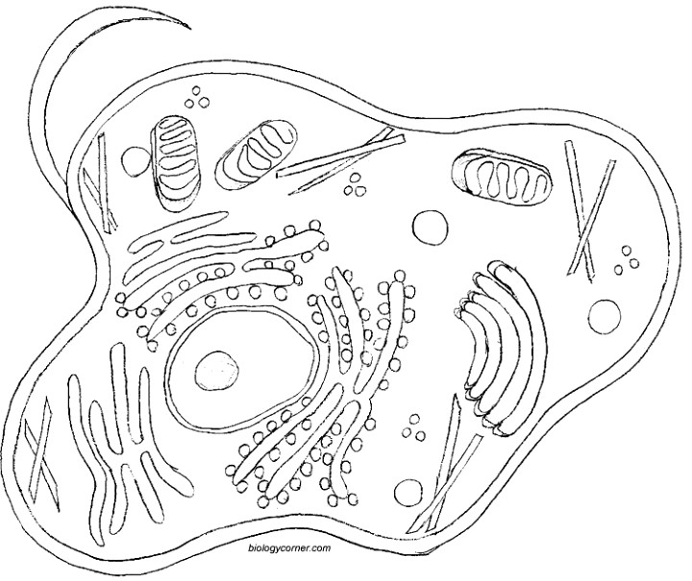
II. Briefly describe the function of the cell parts.
1. Cell membrane | 5. Lysosome
2. Endoplasmic Reticulum | 6. Microtubule
3. Ribosome | 7. Mitochondria
4. Golgi Apparatus | 8. Nucleus

Plant Cell Coloring

I. Directions: Color each part of the cell its designated color.

Cell Membrane (orange)  Nucleoplasm (yellow)  Mitochondria (red)  Vacuole (light Blue)  Chromatin (gray) | Cell Wall (dark green)  Nucleolus (brown)  Chloroplasts (light green) | Ribosome (purple)  Cytoplasm (white)  Golgi Apparatus (dark blue)
Smooth Endoplasmic Reticulum (pink)
Rough Endoplasmic Reticulum (pink)
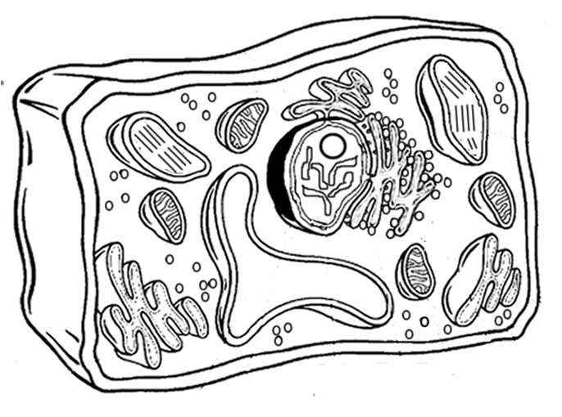

Analysis
1. Name two things found in a plant cell that are not found in an animal cell:
2. What is the function of the chloroplasts?
3. What is the function of the vacuole?

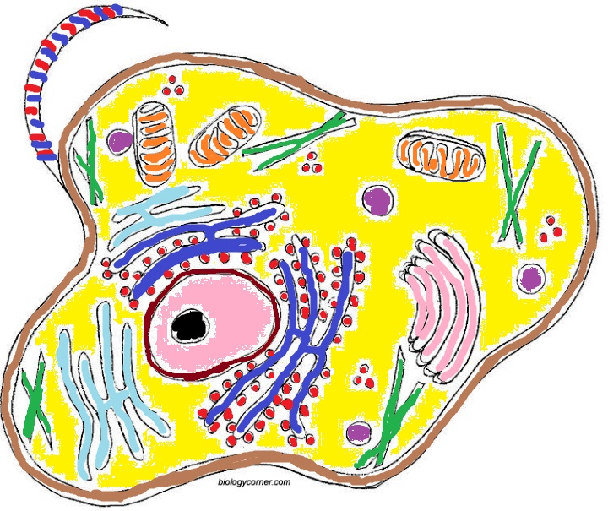
Animal Cell Coloring KEY

II. Briefly describe the function of the cell parts.
1. Cell membrane: barrier between cell and outside
2. Endoplasmic Reticulum: cell transport
3. Ribosome; makes proteins
4. Golgi Apparatus: packaging, processing, secreting vesicles
5. Lysosome: breaks down substances
6. Microtubule: cytoskeleton, cell support
7. Mitochondria: produces energy for cell; cell respiration
8. Nucleus : control center, contains DNA

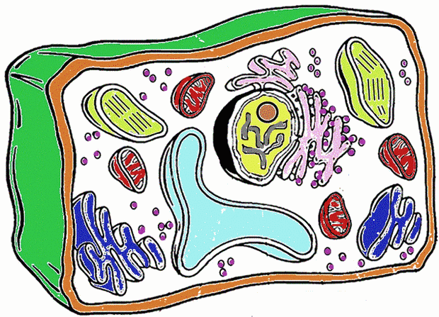

Animal Cell Coloring KEY

Analysis
1. Name two things found in a plant cell that are not found in an animal cell: chloroplast, cell wall
2. What is the function of the chloroplasts? photosynthesis
3. What is the function of the vacuole? stores water

