Biology Fall Final Exam Study Guide KEY

Energy
- How do organisms in an energy pyramid obtain their energy? Photosynthesis for producers or consume other organisms

- Which level in an energy pyramid has the most available energy? Producers (bottom)

- Define chemical energy, thermal energy, potential energy, kinetic energy, and mechanical energy.
Chemical energy: energy in bonds
Thermal energy: energy of heat
Potential energy: energy of position
Kinetic energy: energy of motion
Mechanical energy: energy used to do work

- What is energy that is given off from a reaction lost to the environment as? Heat

- What is the chemical equation for cellular respiration?
6 O₂ + C₆H₁₂O₆ → 6CO₂ + 6H₂O + energy (ATP)

- Do plants perform cellular respiration? YES! Mitochondria

- What is the chemical equation for photosynthesis?
6CO₂ + 6H₂O + energy (light) → 6 O₂ + C₆H₁₂O₆

- What is fermentation? Respiration without oxygen
- What types of organisms perform fermentation? Fungi, Bacteria
- What are the two types of fermentation? Lactic acid, alcoholic
- Which compound that is produced by respiration directly provides us with energy? 36 ATP

Enzymes
- What is an enzyme?
Protein that speeds up chemical reaction (catalyst)

- How does an enzyme affect a reaction rate?
Speeds it up

- What does an enzyme do to activation energy?
Lowers it

- What are 3 characteristics of an enzyme?
Shape determined by amino acid sequence, Unchanged in reaction, Specific for reaction

- Draw an enzyme-substrate complex.
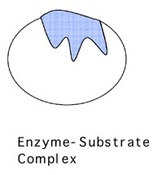

- What does temperature do to an enzyme?
Changes protein (denatures) = decreased or no reaction

- Define Catabolic Reaction and Anabolic Reaction.
Catabolic: breaks apart
Anabolic: builds

Proteins
- What are the monomers of proteins?
Amino Acids

- How does temperature affect proteins?
Changes shape (denatures)

- Define the 4 structures of a protein. (Primary, Secondary, Tertiary, Quaternary)
1 = sequence of amino acids, 2 = folding/spirals, 3 = complete protein, 4 = groups of proteins

- Which part of an amino acid makes it unique?
Side chain (R-group)

- Draw the structure of an amino acid.
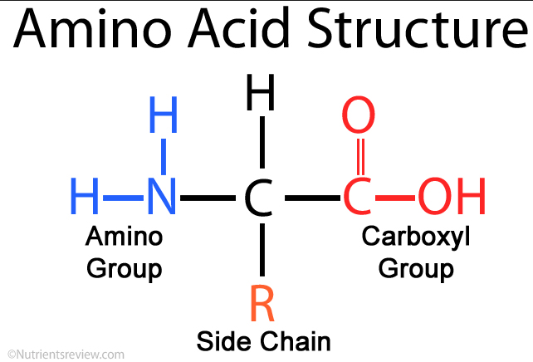
- What element does a compound need to contain in order for it to be considered organic? Carbon

- What elements are in a protein? CHNO

Carbohydrates
- What is the function of a carbohydrate? Provide energy
- What are the monomers of carbohydrates? monosaccharides
- What elements are in a carbohydrate? CHO
- What is a monosaccharide, disaccharide and polysaccharide? Mono: glucose, Di: Lactose, Poly: Starch
- Draw or write out the insulin, glucagon feedback loop.
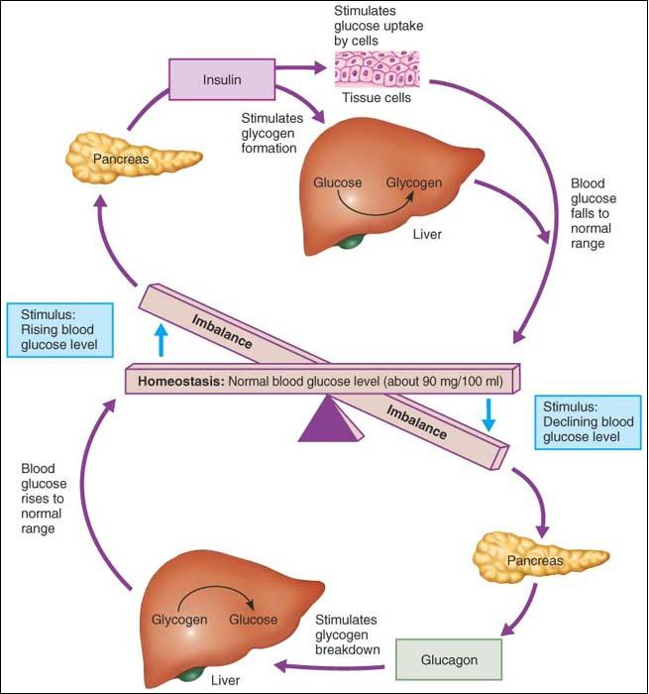

- What is the function of insulin? Glucagon? Glycogen?
Insulin: opens the cells for glucose (Think: Glucose IN)
Glucagon: signals the liver to change glycogen into glucose (Think: Glucose is gone)
Glycogen: storage of extra glucose

- What causes lactose intolerance?
Lack of lactose enzyme to break down lactose

Lipids and Cell Transport
- What are the differences between a saturated and unsaturated fatty acid?
Unsaturated has a fatty acid (bent)

- What are the characteristics of a phospholipid?
Phospholipids consist of a two fatty acids tails (nonpolar, hydrophobic), a glycerol molecule neck, and a phosphate head (negatively-charged polar, hydrophilic polar) head, which is hydrophilic.

- What are the functions of the cell membrane?
Regulate what enters and exits the cell, identification, maintain homeostasis

- What are the channels that span the membrane made of? Protein

- What are the 3 types of Passive Transport?
Simple Diffusion, Osmosis, Facilitated Diffusion

- What is diffusion? Movement of molecules from areas of high to low concentration
- What is facilitated diffusion?
Diffusion using a transport protein to allow molecules to pass through the cell membrane.

- What is osmosis?
Movement of water through a semi-permeable membrane

- What is active transport?
Movement of molecules that requires the input of energy (Think: Active Transport Protein = ATP)

- Define Endocytosis and Exocytosis?
Endocytosis – movement of materials into a cell using vesicles formed from the cell membrane
Exocytosis – movement of materials out of a cell using vesicles formed from Golgi body

- Define hypotonic, hypertonic and isotonic.
Hypotonic = solution low in solutes so water moves into the cell
Hypertonic = solution high in solutes so water moves out of
the cell
ISOTONIC = solution has same amount of solutes as the cell

